Savoy Cabbage Information Pack
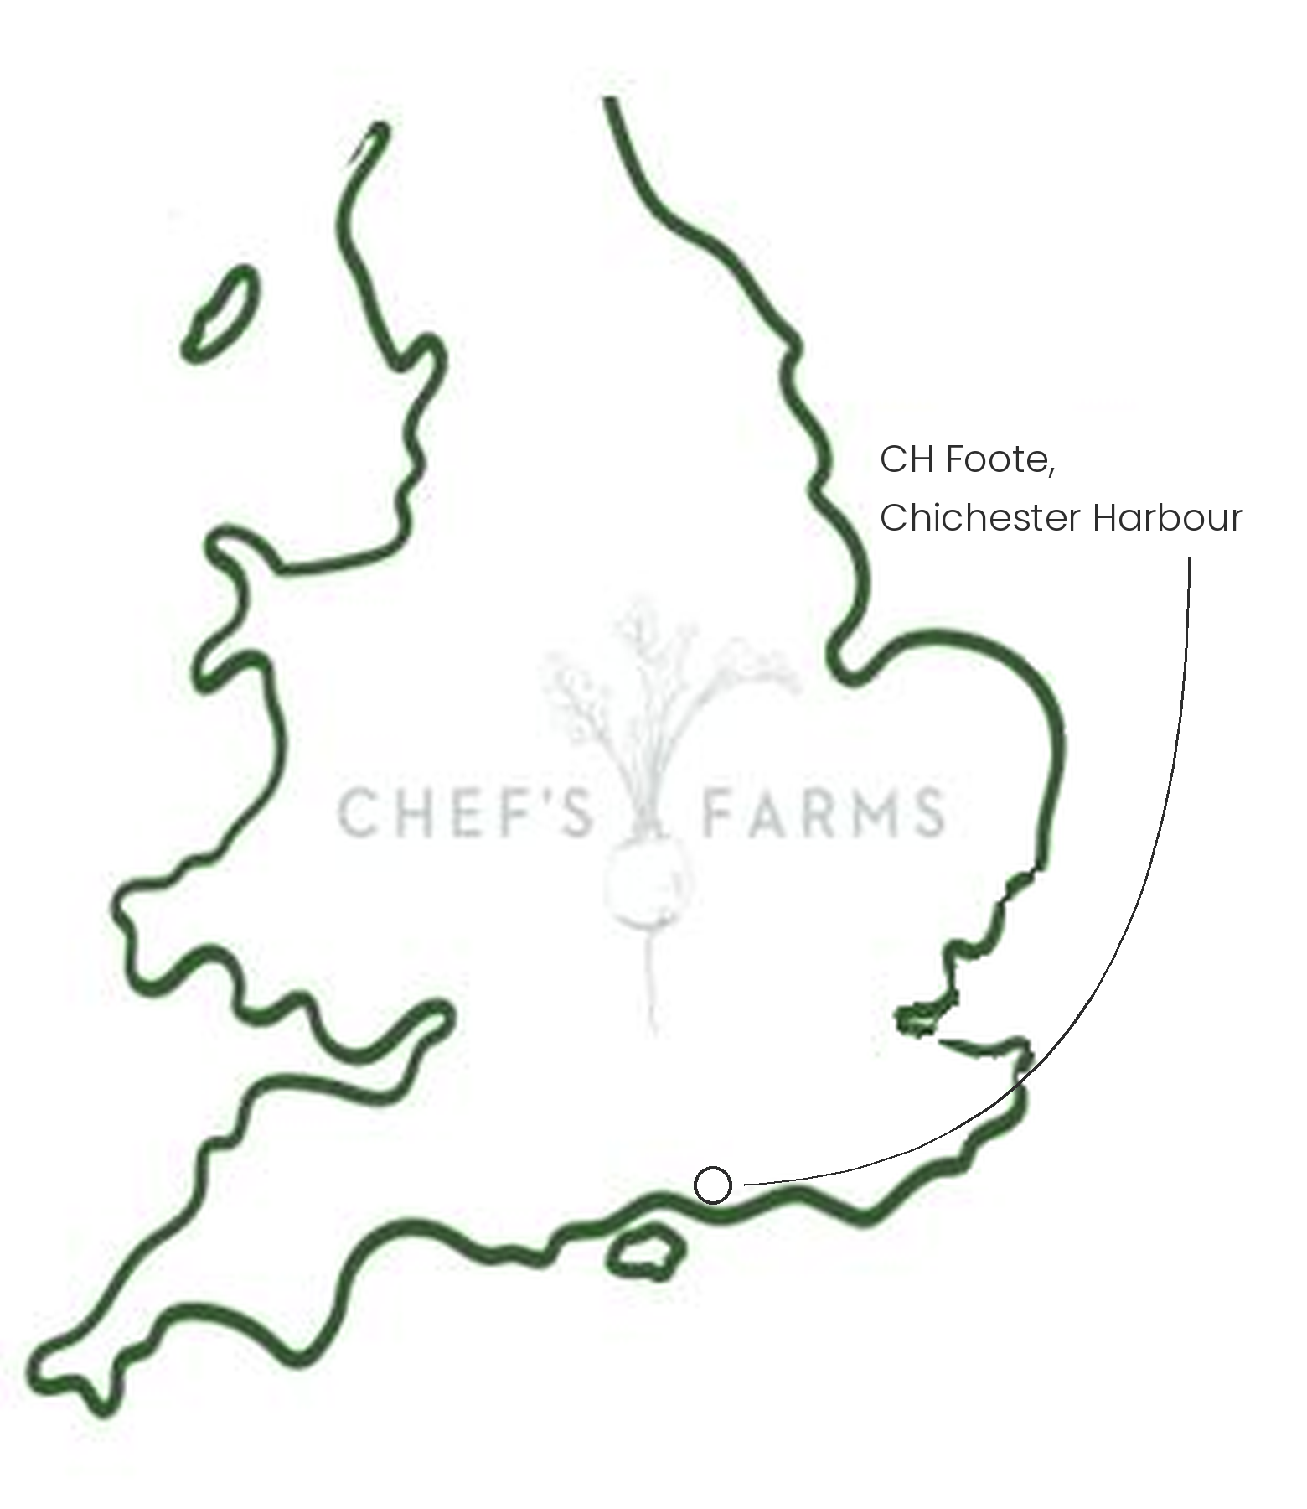
Introduction
Savoy is a winter cabbage, recognisable by its deeply crinkled leaves. These hold onto butter and sauces well and are soft enough to wrap and stuff without tearing.
Farm Information
Our Savoy cabbage is grown by CH Foote, down by the water at the top of Chichester Harbour, the same family team that grows our purple sprouting broccoli. The well drained, sandy soil here is rich in nutrients and perfect for growing vegetables.
Savoy is a proper hardy brassica. It sits in the field through the coldest months and actually improves with a frost, as the plant converts some of its starch into sugar to protect itself, giving a sweeter, milder head.
Like all brassicas, cabbages are a favourite of the cabbage white butterfly and the local pigeons. These growers are brassica experts and grow their crops in strips rather than one large block, breaking up the monoculture and keeping the pests 'on their toes' as it were. Nets keep the pigeons off, and a carefully planned crop rotation keeps the soil fertile, so very few agrichemicals are needed.
These growers have grown the farm significantly in this generation. We are incredibly proud to support them.
More
Savoy is at its best from late autumn through the winter, a reliable workhorse when the choice of fresh greens is at its thinnest. Shred it finely and sauté in butter, or blanch whole leaves for wrapping.
Nutritionally, Savoy is a good source of vitamin C, vitamin K, folate and fibre.
Media
See shared album

